COS 214 Practical 3
Code Masters
Team Members:
Kyle Pillay - 23545756
Takunda Mugwagwa
Brett Pitts

1.1 PixelCon is a one-day gaming convention held across a single indoor/outdoor venue. Attendees move between gaming halls, a competitive tournament zone, and an outdoor plaza containing food, merchandise, and ticketing. The event runs on a live coordination system: a central control point can issue notices, schedule changes, capacity warnings, weather alerts, and evacuation instructions, that must reach the correct operational units without any single class needing to know about every other class in the venue.
The venue is large enough to justify nested structure. The root event contains multiple halls: one hall contains a further nested zone dedicated to tournament play; and every hall contains several individually reactive operational units. This gives PixelCon three levels of Composite nesting below the root, and units that behave meaningfully differently from one another even though they all respond to the same shared interface.
Groupings / areas
- PC Hall — houses PC gaming stations and VR demo booths, plus a nested sub-zone.
- Tournament Zone — nested inside PC Hall; hosts the competitive bracket play for the event.
- Console Hall — houses console and handheld gaming stations, plus an information desk.
- Outdoor Plaza — houses mobile gaming, food, merchandise, and ticketing — the only area directly exposed to weather.
Concrete event units
- PC Station — a desktop gaming seat. Indoor unit; ignores weather alerts entirely, but shuts down immediately on evacuation.
- Console Station — a console gaming seat. On close, finishes and saves any active session rather than dropping it instantly.
- Switch Station — a portable handheld station. Runs in a reduced-capacity "portable mode" and otherwise ignores most notices except evacuation.
- VR Booth — a VR demo pod. Enforces a cooldown period before it can reopen after closing, and pauses new sessions (without cutting off an in-progress one) during a capacity alert.
- Tournament Desk — manages bracket registration and round scheduling, reacts to schedule-change notices by delaying the active round.
- Info Desk — never fully closes, only reduces staffing; updates its announcement board in response to every notice type it receives, unlike most units which only react to specific ones.
- Merch Vendor — reinterprets "capacity" as remaining stock rather than headcount, and flags itself for restock during a capacity alert.
- Food Vendor — the one indoor-vs-outdoor-sensitive vendor: actually closes on a weather alert,and finishes a mid-order before shutting down.
- Mobile Station — a lightweight mobile-gaming station with near-instant open/close and a queue that reshuffles on schedule changes.
- Ticket Booth — the only unit that stays locked shut after an evacuation until an explicit resume notice arrives, rather than reopening freely.

1.2
Main plays the clients for all.
Composite pattern participants
- Component = EventComponent
- Composite = EventGroup
- Leaf = EventUnit and its ten concrete descendants: PCStation, ConsoleStation, SwitchStation, MobileStation, VRBooth, TournamentDesk, InfoDesk, MerchVendor, FoodVendor, TicketBooth
- Client = main.cpp
Observer pattern participants
- Subject = Subject (abstract)
- ConcreteSubject = EventGroup, EventControl
- Observer = Observer (abstract)
- ConcreteObserver = EventGroup, and the ten concrete EventUnit descendants listed above

EventGroup participates in three roles:
- As Composite, it owns and recurses over its children.
- As ConcreteSubject, it can have observers attached to it (typically, but not necessarily, its own children) and pushes notices to them.
- As ConcreteObserver, it can itself be registered with a parent EventGroup (or with EventControl), so a notice issued above it is received via update() and then re-broadcast downward via its own notify(). This is what makes a notice cascade through multiple tree levels.
EventUnit (and every concrete leaf),participates in two roles:
- As Leaf, it is a terminal node in the Composite.
- As ConcreteObserver, it can be attach()ed to whichever EventGroup contains it and reacts to notices via update().

1.3
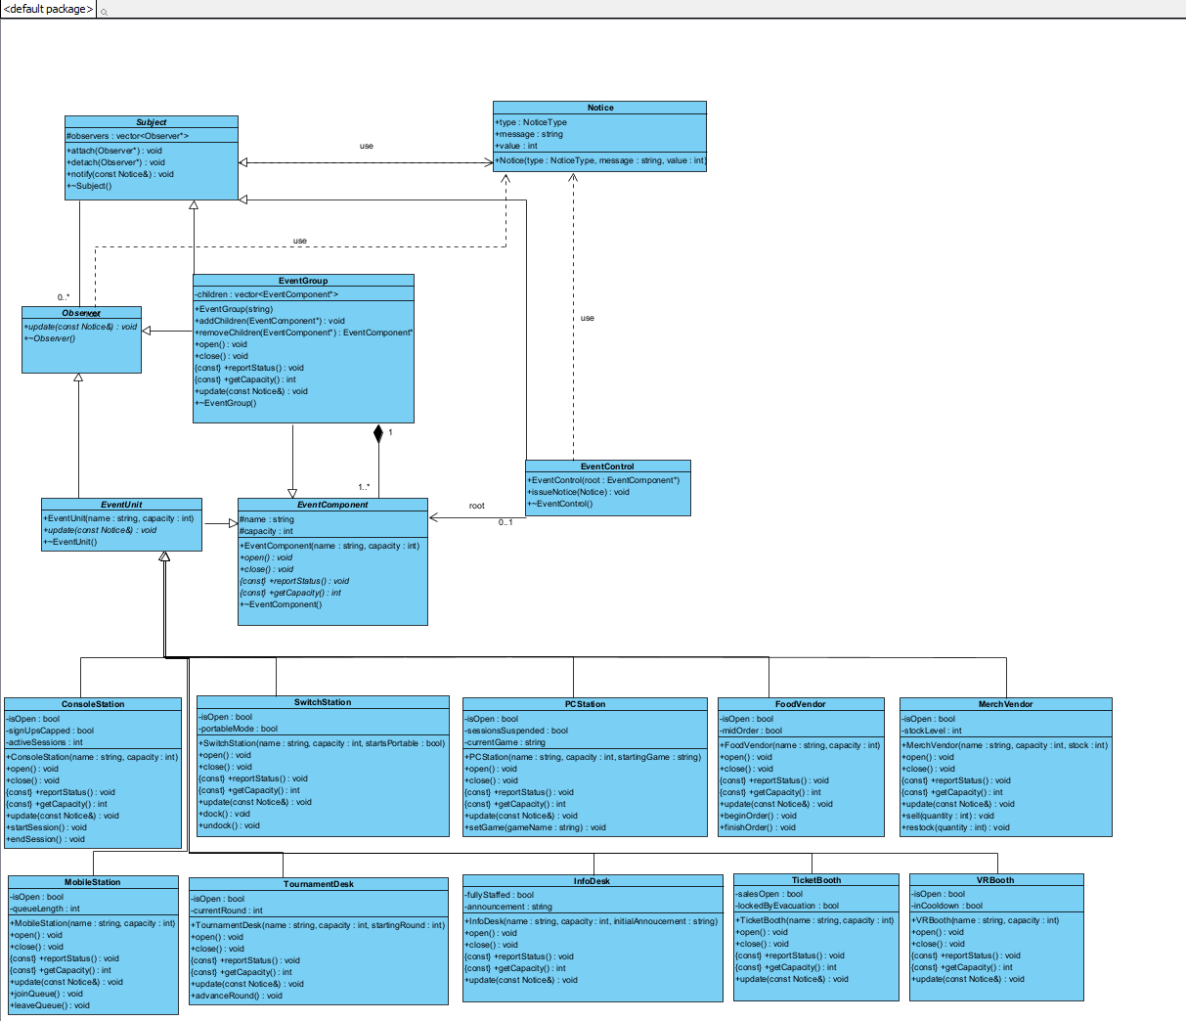

1.4
a) Composite as a genuine part-whole tree. EventGroup doesn't just reference its children, it owns them: each child is added via addChildren(), belongs to exactly one group, and is deleted when that group's destructor runs. Since a child can itself be an EventGroup, deletion recurses, delete pixelCon releases the entire subtree. That ownership contract is what makes it a tree, not a plain list.
(b) Why Observer is required. Without it, EventControl would need to hard-code a call to every concrete unit for every notice, rewritten each time a unit moves or changes. attach/detach/notify let a subject broadcast to whoever is currently registered without knowing their concrete type.
(c) Who owns event components. EventGroup owns its children exclusively, addChildren() takes ownership, ~EventGroup() deletes each child once, and removeChildren() hands ownership back without deleting, so a unit can be safely re-parented. The root is owned by whoever creates it in main.cpp.
(d) Who owns observer references. Subject never owns its observers, observers is a vector of raw, non-owning pointers, and ~Subject() just clears the list. lifetime is decided by the Composite tree, registration is a freely changeable relationship. If Subject owned observers too, moving a unit between groups would risk a double-free.
(e) Why EventGroup being Subject and Observer isn't a misuse. Ownership lives in children; notification lives in observers; being notified is a third link entirely, tracked by nothing more than being attached somewhere. addChildren() never auto-attach()s, so a child can be structurally contained without listening for notices, proving the two collaborations stay genuinely separate even when the same object plays both roles.
2.3
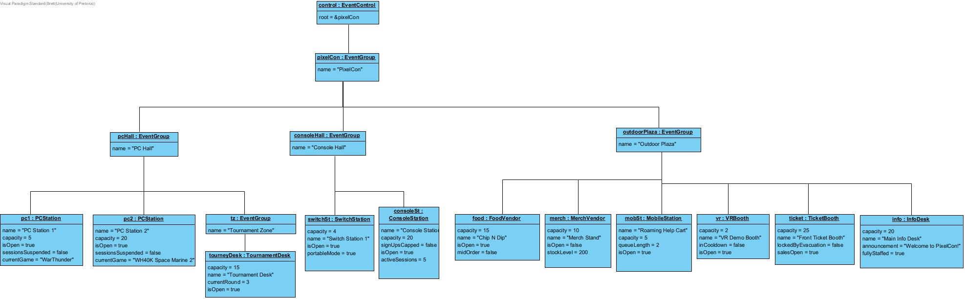

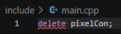
2.4

pixelCon owns its child EventComponent* pointers inside its children vector. Its destructor recursively loops through and deletes each child element, ensuring every object allocated with new in main.cpp is released exactly once — because each child belongs to exactly one group at a time, delete pixelCon triggers a cascade through pcHall, consoleHall, and outdoorPlaza, and each of those destructors deletes their own children in turn, all the way down to tourneyDesk. No object is ever owned by two groups at once, so nothing gets deleted twice and nothing leaks.

If an object is transferred between composites, the ownership rule is: only one EventGroup may own it at any moment. removeChildren(child) hands ownership back to the caller without deleting it (and also detaches the child as an observer if it was registered), and the caller must immediately re-parent it via another group's addChildren(child) before that pointer is dropped. This is exactly what happens in main.cpp when mobileStation is relocated from outdoorPlaza to consoleHall: outdoorPlaza->removeChildren(mobileStation) releases ownership, then consoleHall->addChildren(relocated) re-establishes it, so the object is never owned by two groups at once and never left owned by none.
attach(observer) first rejects nullptr, then linearly scans observers for the pointer already being present; if it's found, attach() is a no-op and the observer is not added twice — this prevents notify() from ever calling update() on the same observer more than once per notice. If the pointer isn't already registered, it's pushed onto the back of the vector.

detach(observer) scans for a matching pointer and erases it if found; if the observer was never registered (or was already detached), detach() simply does nothing and returns — no error, no crash, just a safe no-op either way.

Both methods treat observers purely as a set of raw, non-owning identities: Subject never owns or deletes what these pointers point to (see ~Subject(), which only calls observers.clear()), so attach/detach are just membership toggles on that list, not lifetime operations. This keeps the policy simple and predictable: calling attach() twice is harmless, calling detach() on something not present is harmless, and neither can leave the list in an inconsistent state.

3.2)
Observer implementation and lifetime safety. Observer is a pure abstract base with one pure virtual method, update(const Notice&), and a virtual destructor that does nothing itself (Observer::~Observer(){}), it holds no state, so there's nothing for it to clean up on its own. EventUnit inherits from both EventComponent and Observer, giving every concrete leaf a dual role: Leaf in the Composite tree, and ConcreteObserver reacting to notices. EventUnit::update() stays pure virtual, forcing every concrete leaf (TicketBooth, VRBooth, etc.) to define its own reaction, and EventUnit's own destructor is empty since it owns no resources itself, each concrete leaf's destructor handles anything it individually added.

Our design does not rely on observers detaching themselves in their own destructor. Instead, it guarantees lifetime ordering structurally, through ownership: every EventUnit is owned by exactly one EventGroup, and that same EventGroup is responsible for cleaning up its registration before it's ever destroyed.

3.4
Causes:
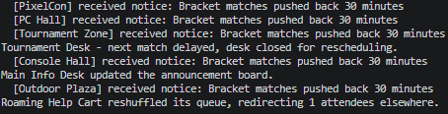
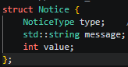
3.5 We use push as notify() passes a full Notice straight into update(const Notice&) observers never call back for more data.

Trade-off. no stored current state, no back-reference needed from observer to subject and we don’t have to call many functions to figure out what the notice is about. The cost is rigidity ,every notice type has to fit the same Notice shape, even for leaves. Pull would scale better if observers needed very different data but would require each observer to know its subject's interface. For EventFlow's small, uniform notices, Push is the simpler fit.

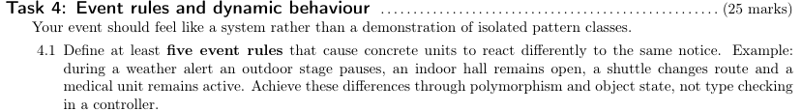
4.1

Rule 1: WEATHER_ALERT distinguishes indoor from outdoor units.
FoodVendor::update() calls close() on WEATHER_ALERT because it's an outdoor unit, with an explicit comment marking it as such. PCStation::update() has a WEATHER_ALERT case that does nothing (comment: // indoor unit), and ConsoleStation/SwitchStation/MerchVendor don't even list WEATHER_ALERT as a case, falling to default: break. MobileStation reacts a third way — clearing its queue but staying conceptually open, since it can physically relocate rather than shutting down. Same notice, three distinct polymorphic responses driven by what kind of unit each object is.

Rule 2: CAPACITY_ALERT produces suspension in some units, cosmetic logging in others, and silence elsewhere.
TicketBooth stops selling (salesOpen = false), PCStation and VRBooth suspend/cooldown their sessions, ConsoleStation caps sign-ups (halving effective capacity), while MerchVendor only logs a "flagged for restock" message without changing any state, and SwitchStation/FoodVendor/TournamentDesk ignore it entirely.

Rule 3: EVACUATE triggers graceful shutdown with different "cleanup" semantics per unit.
ConsoleStation::close() saves active sessions before shutting down. FoodVendor::close() finishes the current order first. TicketBooth doesn't just close — it sets lockedByEvacuation = true, meaning it will refuse to reopen even if open() is called again, until a RESUME notice clears the lock. VRBooth force-ends its session and enters cooldown. Same trigger, four different shutdown behaviors, each expressed through the object's own state and close() override rather than a shared branch.

Rule 4: RESUME doesn't just "undo" — it's asymmetric with what caused the suspension.
TicketBooth::update() on RESUME only clears lockedByEvacuation — it does not automatically reopen sales (salesOpen stays false until someone explicitly calls open()), reflecting that "cleared to resume" and "actually open" are different states. PCStation and VRBooth clear their suspension flags directly. TournamentDesk goes further and reopens immediately, printing which round resumes. ConsoleStation un-caps sign-ups. This shows RESUME isn't a single uniform "reverse everything" branch — each unit decides what resuming actually means for it.

Rule 5: SCHEDULE_CHANGE affects queue-based units differently from fixed-session units.
MobileStation::update() redirects part of its queue (min(queueLength, notice.value)), using the notice's numeric value field meaningfully. TournamentDesk::update() closes the desk entirely for rescheduling. InfoDesk just updates its announcement board text. Units like SwitchStation, FoodVendor, and MerchVendor don't react at all (no case for it) — showing the same notice type produces a spectrum from "hard close" to "text-only update" to "no reaction," entirely through each leaf's own update() override.

All five are achieved purely through each concrete leaf's own state and its override of update() — there's no central if (typeid(x) == ...) dispatch anywhere; EventGroup::update() just cascades the notice via notify(), and each leaf decides its own reaction.
4.4
Feature 1: Lockout states that outlast their triggering notice.
TicketBooth's lockedByEvacuation flag and VRBooth's inCooldown flag both create a state that persists independently of the immediate notice — a locked ticket booth refuses open() calls entirely until explicitly cleared by RESUME, and a cooling-down VR booth refuses new sessions until RESUME arrives too. This adds a believable "can't immediately snap back to normal" behavior without any single class growing new responsibilities — each leaf just tracks one private bool and checks it in open().

Feature 2: Stock-based capacity semantics (MerchVendor).
Rather than every leaf's getCapacity() meaning "seats/headcount," MerchVendor::getCapacity() deliberately repurposes the same virtual interface to mean "remaining stock," with sell()/restock() operations that never let stock go negative. This shows the common EventComponent interface can carry different real-world meaning per leaf while still aggregating sensibly through EventGroup::getCapacity()'s summation — no changes needed anywhere else in the tree.

Feature 3: Order-in-progress tracking (FoodVendor).
FoodVendor::beginOrder()/finishOrder() track whether a customer transaction is mid-flight, and close() checks this before shutting down, printing a "finishing current order before closing" message rather than cutting off service instantly. This is a small but genuine behavioral difference from ConsoleStation's similar "save active sessions" idea, showing the same concept (graceful shutdown) implemented as a different mechanic per leaf, which avoids the two classes converging into copy-pasted logic.

Each of these stays contained to a single leaf's private state and its own overridden methods — none of them require EventGroup, EventControl, or main.cpp to know about the specific leaf type, so no class becomes a god object coordinating behavior on others' behalf.
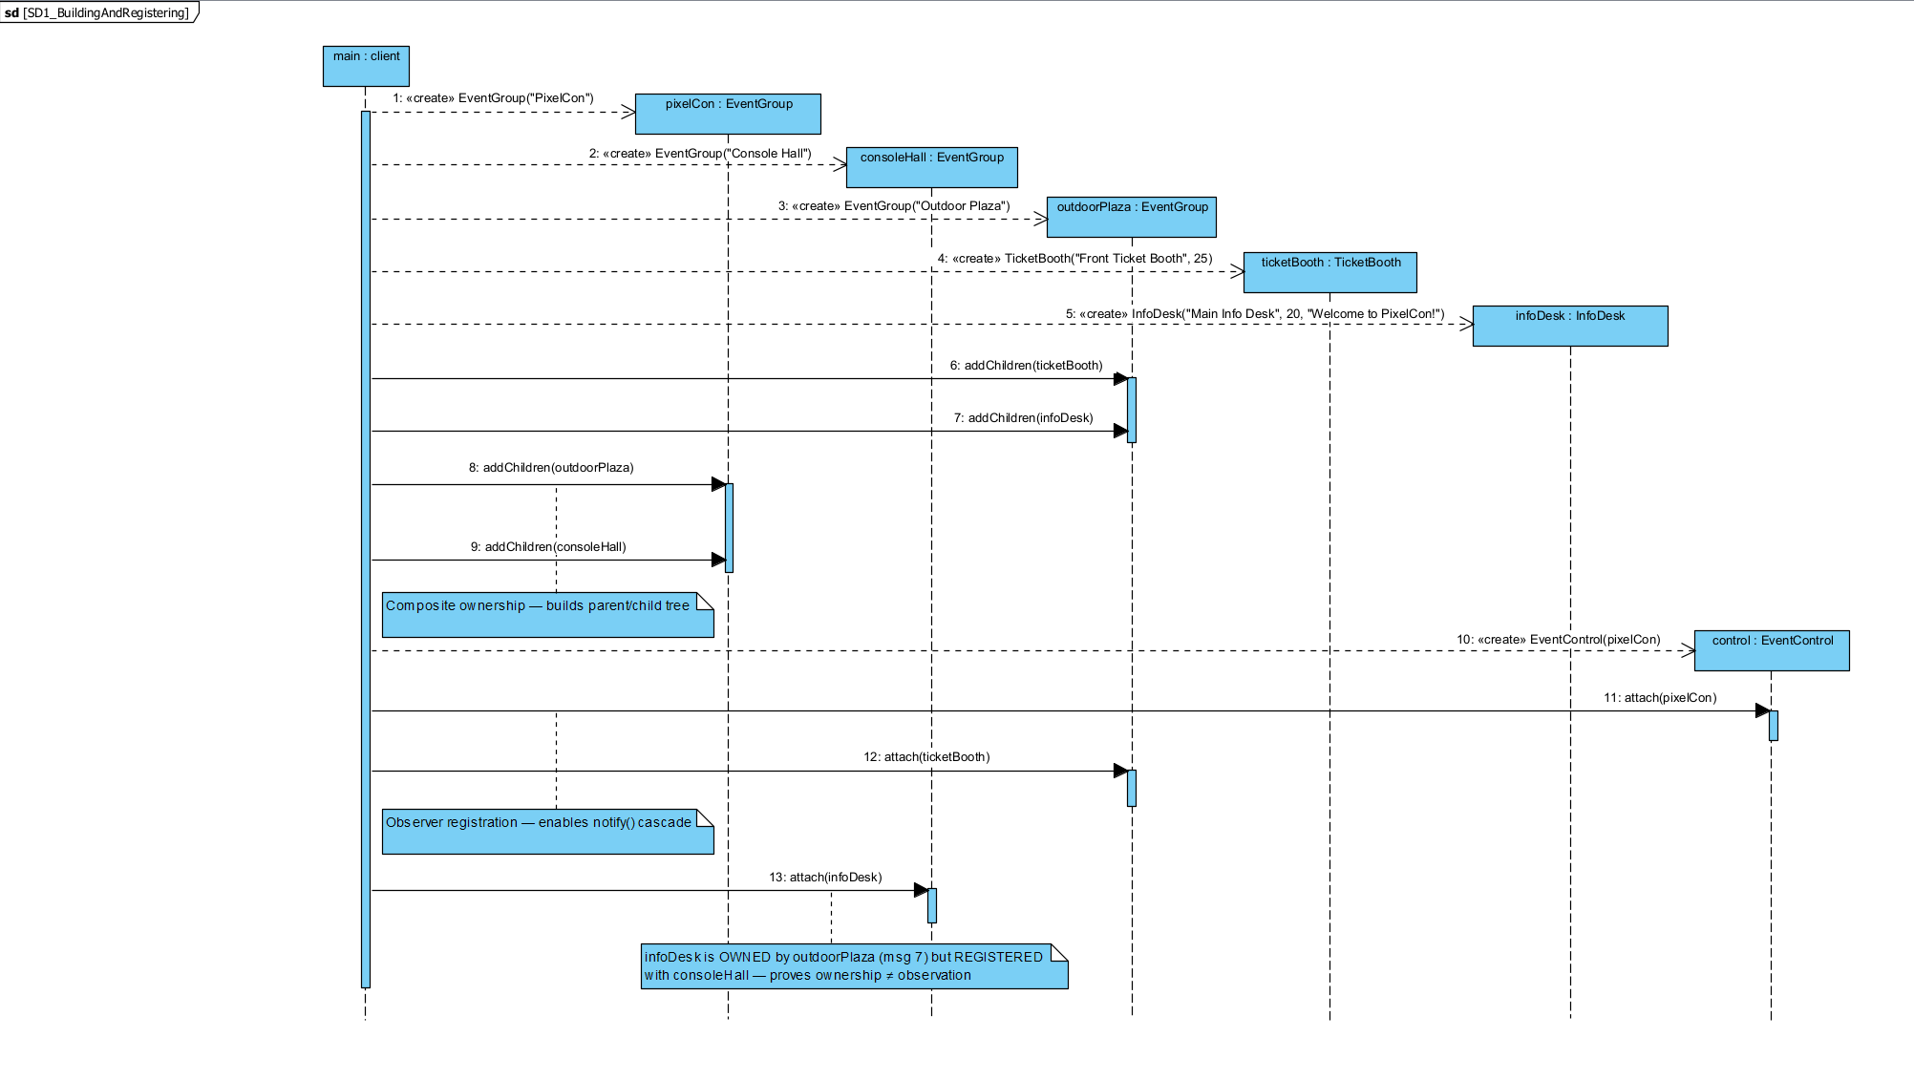

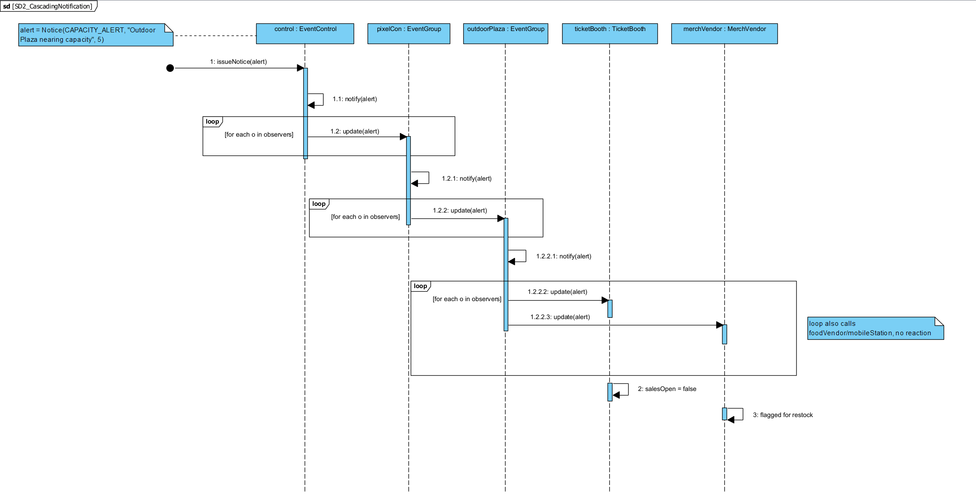

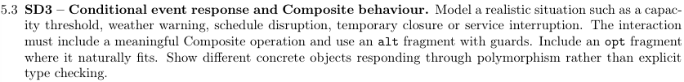
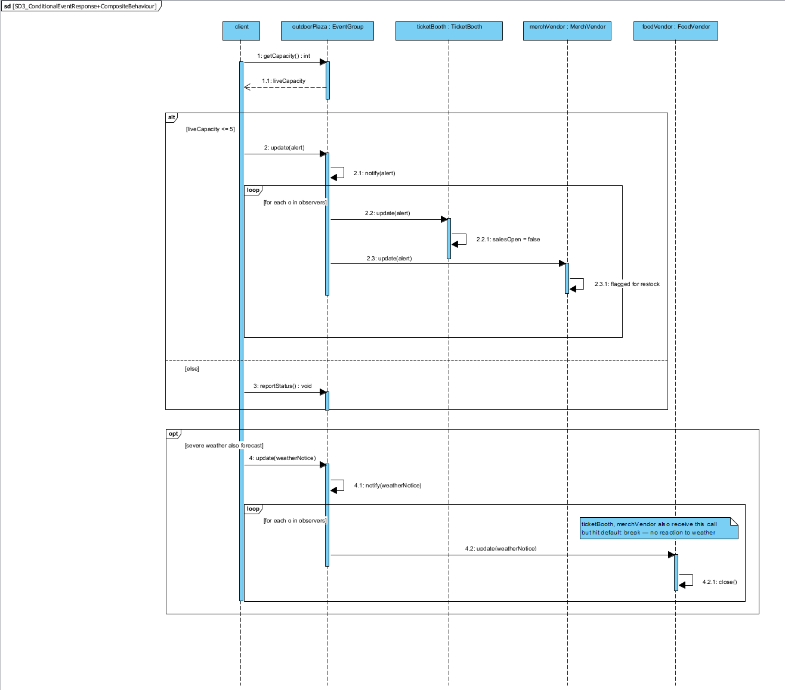
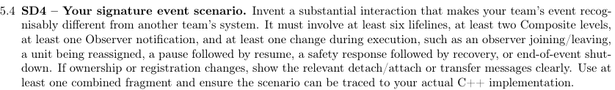
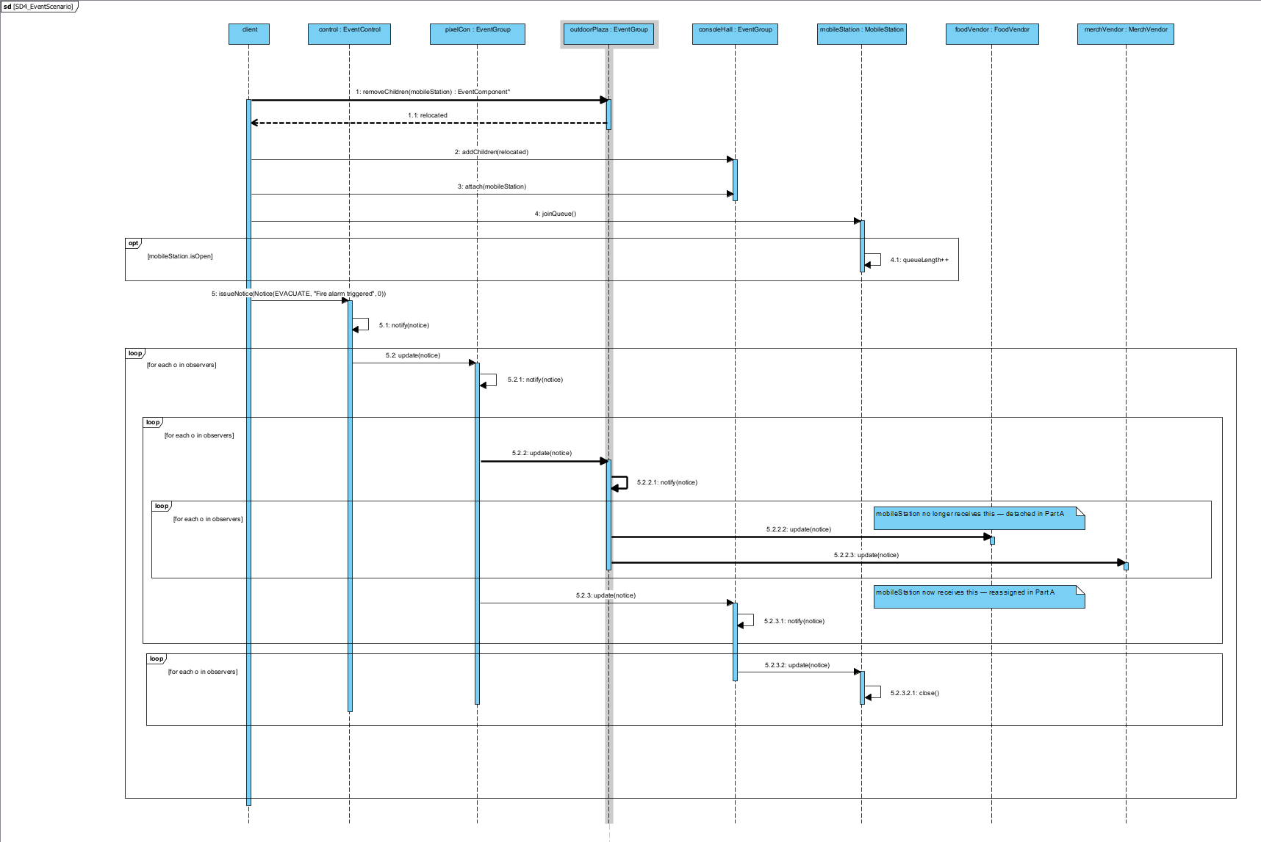

Here

Kyle completed:
1. Made Main UML diagram
2. Completed all sequence diagrams
3. Completed question 4.1, 4.4, fixed 2.4, added 3.1, 3.2
Takunda completed:
1. Coded 5 leaves
2.
3.
Brett completed:
1. Updated UML for 10 leaves
2. Completed Object diagram
3. Completed Questions 1.4, 2.1, 2.2, 2.3, 2.4, 3.1, 3.2, 3.3, 3.4, 3.5, some of Question 6

The team coordinated its work through branching and pull requests before merging to main. We used WhatsApp as a primary source of communication and reviewed each other’s work where necessary before committing and adding on or fixing each other’s work where possible. If improvements could be made, communication was made and a solution was reached before any major changes were committed to ensure reliability and reduce possible errors. The team coordinated its work through branching and pull requests before merging to main. We used WhatsApp as a primary source of communication and reviewed each other's work where necessary before committing or adding on or fixing each other's work where possible. If improvements could be made, communication was made and a solution was reached before any major changes were committed to ensure reliability and reduce possible errors.
Three commits that show this in practice: Brett's "Merge pull request #7 from KP23545756/feature/first5leaves+makefile" followed shortly by "Fixed errors and makefile" shows a branch being reviewed, merged, and then repaired once integration issues surfaced like the review-before-major-changes process described above. Kyle's "Fixed naming inconsistency in UML Diagram" commit reflects the class diagram being corrected after a review caught a mismatch with the implemented addChildren/removeChildren methods, rather than being drawn once and left untouched as well as committing the sequence diagrams. Takunda's steady run of incremental commits ("info desk is officially done", "doing last 5 leaves", "ticket booth implementation done") over multiple sessions shows ongoing development across the practical rather than a single end-of-project upload.

Evidence:

Kyle

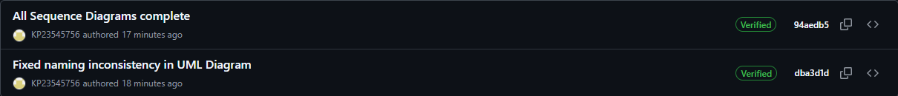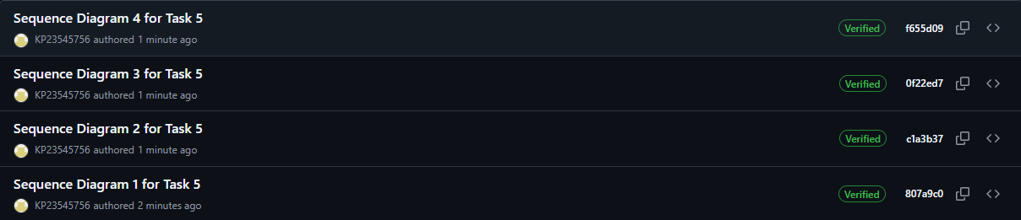

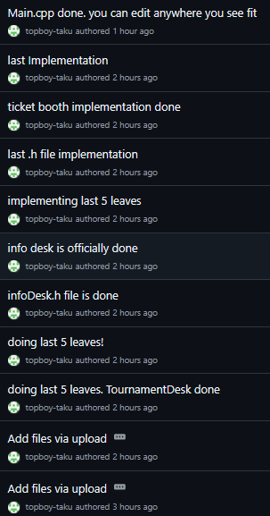
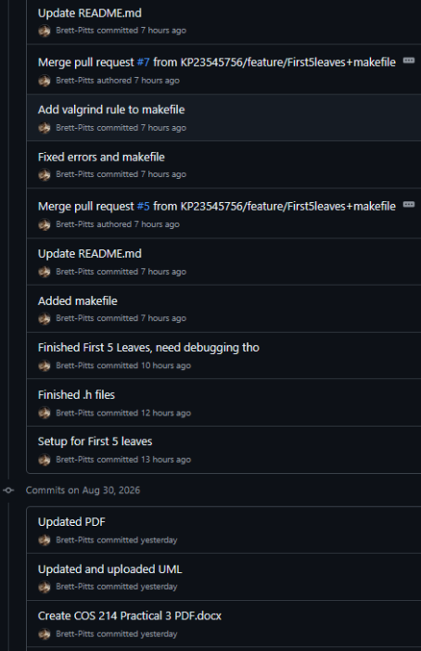

Doxygen Evidence:

